**The great levelling**

**大溃败**

(英文部分选自经济学人20220803财经版块)

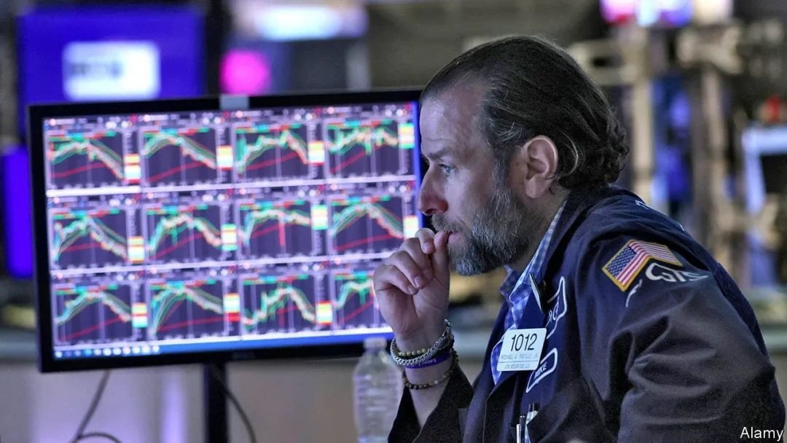

The great levelling

大溃败

An anatomy of this year’s market mayhem

剖析本年度金融市场混乱

**The sell-off has been savage but there are few signs of a crisis. Can that last?**

**虽然抛售已非常猛烈，但几乎无危机迹象。这会持续吗？【出现but，译为“但是”的同时留意前半句，看是否需要增译“尽管”“虽然”】**

After a frantic sell-off **in the first half of the year**, investors are taking a breather. The S&P 500 index of American stocks, for instance, is **back around** the level it was **at the start of June**. **Yet with a little less than five months of 2022 remaining, it would take a turnaround of astonishing proportions to avoid a torrid year in financial markets.** **The period’s distinguishing characteristics are already clear: the slump has been unusually deep and unusually broad.**

**上半年**的疯狂抛售之后，投资者们进入了短暂的“中场休息”。例如，美国股票标准普尔 500指数**差不多回到**了**6月初水平**。**然而现在2022年仅剩下不到5个月，若不想金融市场经历艰难一年，可能需要上演一场惊天大逆转了【it引导的主语从句的翻译 & with引导的伴随状语 & 增译时间状语“现在”】**。**过去几个月的主基调已然非常明晰：大范围的严重衰退**。

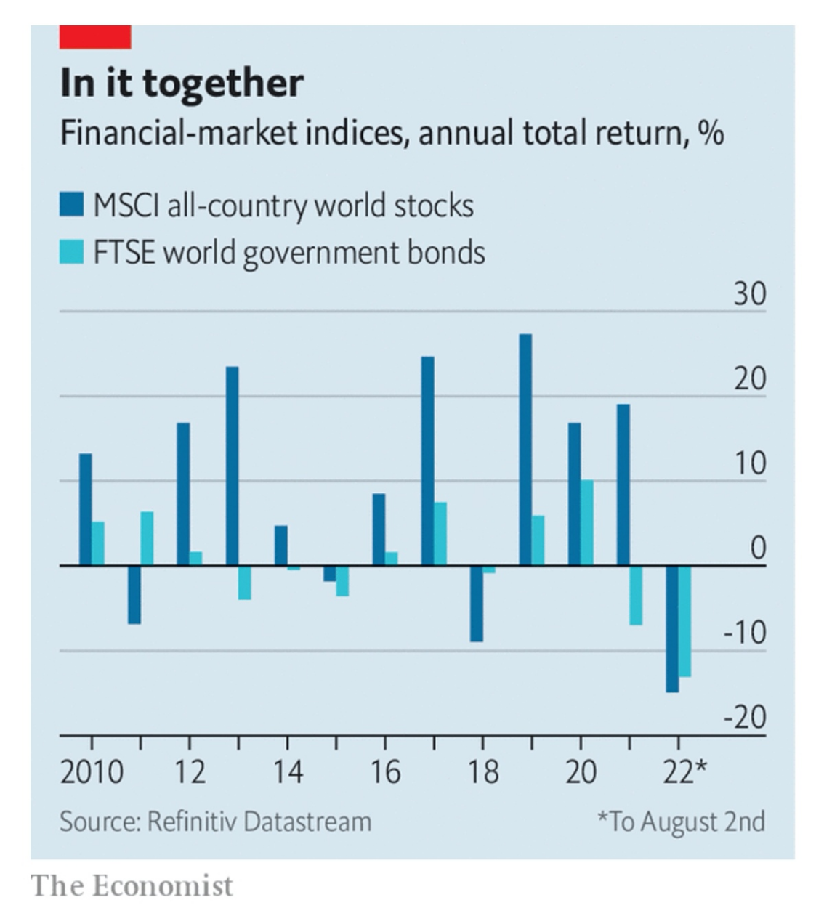

If the year ended now, an investor in the MSCI All Country World Index of global stocks would have lost 15%, **the lowest return since 2008**. The broad-based decline across asset classes has added another element of pain, too. Most obviously, both stocks and bonds have been hammered. **The good news is that distress has been concentrated among a few types of assets and firms.** **Whether that silver lining remains come the end of the year is uncertain.**

如若2022年登时宣告结束，MSCI全球指数（ACWI）的投资者将损失15%——**这是2008年以来的最低回报【补充说明中，可以用“这”代替主语】**。资产类投资回报率的全盘下跌也是另一痛苦来源。最明显的是，市场出现股债双杀的景况。**令人欣慰的是，困境集中在少数几类资产和公司上**。**而这‘黑暗中仅存的一线光明’到年底时是否仍在尚未可知**。

注释：MSCI是摩根士丹利资本国际公司（Morgan Stanley Capital International）的简称，MSCI指数就是摩根士丹利资本国际公司编制的一系列金融市场指数，在中国，这个指数也称为明晟指数。Source: https://www.msci.com/

**Such a coincident fall in stocks and bonds is rare**. When stock prices fall **because of a weakening economy**, bond prices usually rise owing to expectations of interest-rate cuts, bolstering a mixed portfolio. **Conversely, stocks often benefit from a stronger economy, while bonds sell off**. The double dip this time is driven by surging inflation, expected interest-rate rises and a belief that the economic situation will deteriorate. An investment in the FTSE Global World Government Bond Index would have lost 13% so far in 2022, making this the first year since 1986, when the index was established, in which there have been double-digit falls in both stocks and bonds globally.

**这种股债双杀的行情实属罕见**。当股价**因经济疲软【“疲软”，用词不错】**而下跌时，债券价格通常会因预期降息而上涨，使混合投资组合维持稳定收益。**相反地，经济繁荣时，股票常受到青睐，债券则会出现抛售【长句变数个短句】**。这次的股债双探底是由通胀飙升、预期加息以及看衰经济形势的信念所驱动。2022年开年以来，富时世界国债指数（FTSE Global World Government Bond Index）成分债券的投资者们平均损失了13%的本金。这是1986年该指数创立以来全球股票和债券首次双双出现两位数的跌幅。

注释：富时世界国债指数（FTSE Global World Government Bond Index）由富时罗素公司推出。2020年9月25日，富时罗素宣布从2021年10月份起将中国债券纳入富时世界国债指数（WGBI）。Source: <https://www.ftserussell.com/products/indices/world-government-bond-index>

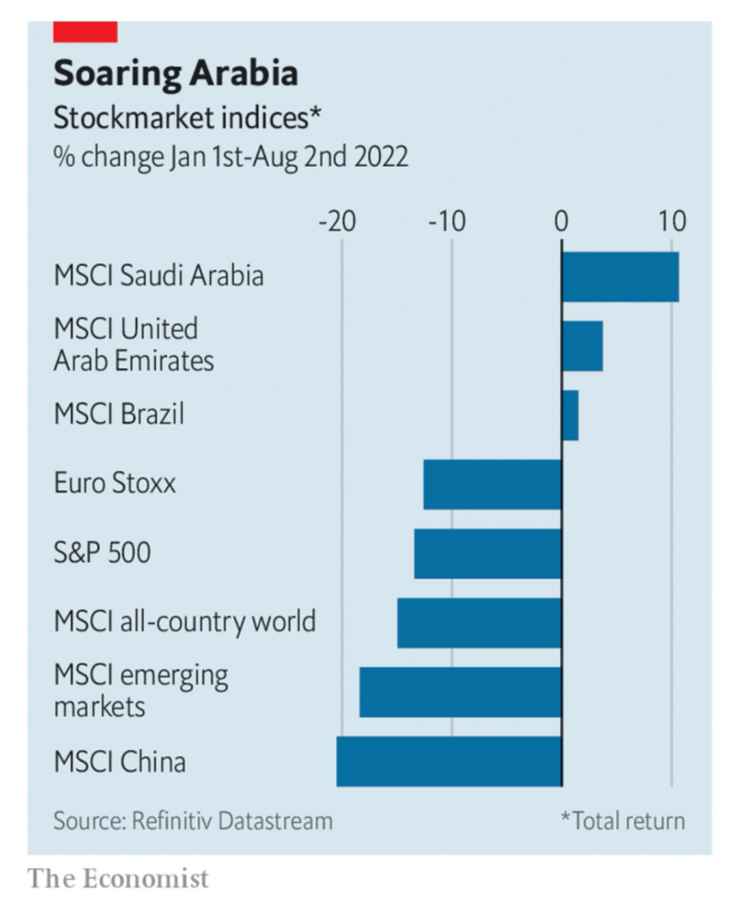

Moreover, equity markets have been battered almost everywhere. Stocks in Europe, Japan and emerging markets are all down. **As a result, there are precious few winners**. The Bloomberg Commodity Index, comprising energy, agricultural and industrial commodities, is up by 18% since January. Oil and gas companies have been bolstered by Russia’s invasion of Ukraine, and the massive disruption to oil and gas supplies that followed. MSCI stock indexes for oil exporters like the United Arab Emirates, Saudi Arabia and Kuwaitare up, as are those for Brazil and Indonesia, which produce other commodities. The msci Chile index is up by more than 20%, but with a market capitalisation of less than $40bn that is not much consolation to investors.

此外，全球股市几乎无一幸免。欧洲、日本及新兴市场股市纷纷下行，**可以说鲜有赢家**。彭博大宗商品指数（the Bloomberg Commodity Index，其中包括能源和工农业大宗商品）自今年1月份以来上涨了 18%。石油和天然气公司受益于俄乌冲突及接踵而至的石油和天然气供应大规模中断。阿拉伯联合酋长国、沙特阿拉伯和科威特等石油输出国的MSCI股票指数尽皆上行，巴西和印度尼西亚作为其他大宗商品生产国，MSCI指数也表现不俗。MSCI智利指数涨幅虽超过20%，但由于其市值还不足400亿美元，因此并没有给投资者带来多少安慰。

注释：Source: https://www.bloomberg.com/company/press/bloomberg-commodity-index-2021-target-weights-announced/

**If you were presented with this degree of misery 20 years ago, you might have expected the odd mainstream financial firm to start looking wobbly.** **Perhaps the most unusual thing of all is** how serious distress so far **has been largely confined to** two groups—both outside mainstream Western finance.

**倒退20年，眼下的悲惨局面或许已经让主流金融机构显得摇摇欲坠**。然而

到目前为止，严重的困境**主要局限于**两个群体，而这两个群体均在西方主流金融范畴之外，**这很不寻常【放在句末翻译】**。

The first is * property developers; sales of which have cratered this year, driven by concerns about the financial health of the companies and the economic impact of protracted covid-19 lockdowns. A bond maturing in January 2024 issued by Country Garden, a developer which until recently held an investment-grade credit rating, now offers **a yield of** more than 100%, up from 5% this time last year. But *’s strict capital controls mean that the turmoil has produced few reverberations outside the country so far. The second place where distress has emerged is the world of cryptocurrency and decentralised finance. Celsius, Terra and Three Arrows Capital, respectively a crypto-oriented lender, a stablecoin and a crypto-oriented hedge fund, have all gone to the wall.

第一个群体是*房地产开发商。市场对公司财务状况的担忧以及疫情防控对经济的影响使得房地产销售额大幅下滑。碧桂园2024年1月到期的美元债收益率超过了100%，而去年同期这一数字仅为5%。近来，碧桂园的信用评级也由投资级下调至垃圾级。好在*严格的**管控之下，目前为止这场动荡对国外市场影响有限。另一领域是加密货币和去中心化金融。加密借贷平台Celsius、稳定币Terra和加密对冲基金三箭资本（Three Arrows Capital）都已穷途末路。

The big question for the rest of the year is whether the pockets of distress will continue to be isolated. Already the strain in emerging markets, which are confronted with rising global interest rates, as well as elevated food and energy prices, is becoming clear. As of late July, around 36% of issuers on the JPMorgan Chase Emerging Market Bond Index had yields above 10%, a figure which **peaked at** only 29% during the market panic in March 2020. Fortunately for the West, its mainstream financial institutions have become less exposed to emerging markets over time.

局部危机是否存在外溢风险，这是今年接下来我们需要面对的重要问题。全球利率大涨，食品能源价格飙升，新兴市场承压已是不争事实。7月底，摩根大通新兴市场债券指数（JPMorgan Chase Emerging Market Bond Index）成分债券中，约有36%收益率超过了10%；而即使是在2020年3月市场恐慌时期，这一比例也始终没有超过29%。幸运的是，西方主要金融机构对新兴市场的风险敞口已在近些年逐步降低。

Another source of angst could be the euro zone if the energy crisis intensifies over the winter: something the European Central Bank tried to **guard against** in July by creating a new mechanism to curb bond-market jitters. And as it has grown harder and more expensive to issue corporate bonds, indebted firms everywhere could face a building funding crunch. **One of the more unusual years in finance over the past few decades is not over yet**.

此外，如若能源危机在冬季加剧，欧元区也同样令人担忧：欧洲央行已于7月出台了应对措施，推出了一套新的机制来回应债券市场的焦虑情绪。而且，由于公司发债的难度和成本越来越高，各地负债企业可能会面临建设资金紧张的局面。**从财经的角度看，今年是过去几十年中极不平凡的一年，在这条不平凡之路上，我们还远没有看到尽头**。